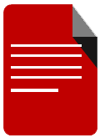

**STUDENT PROFILER**

(Enrollment System)

**Sprint 3**

HALFWAY DOCUMENTATION – March 17, 2017

|  |  |  |
| --- | --- | --- |
| **SCRUM TEAM** | **SPRINT NAME AND DURATION** | **CHANGES** |
| HALFWAY | HALFWAY #2  February 23, 2017  to  February 28, 2017 | * **SP003 –Remove Year Level Page** * **Search Bar is no longer available while editing** |

**SP002 – Student Profile**

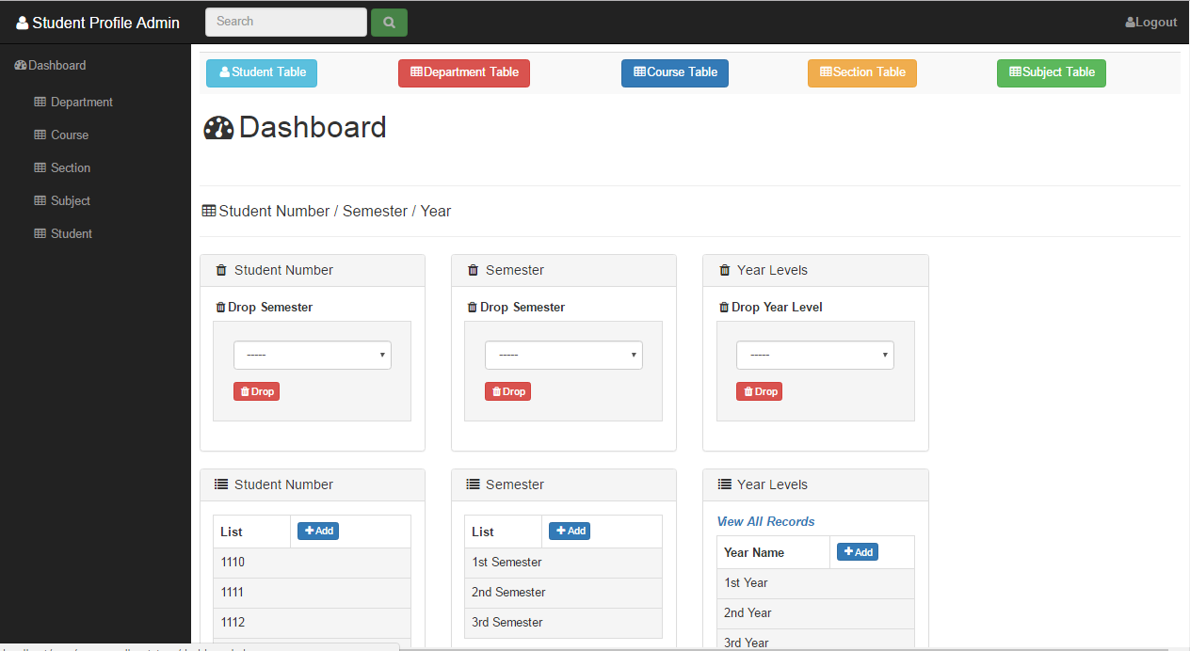

Features (Dashboard)

1. Navigation bar – Use to link the other pages and a search bar for corresponding table.
2. Tables – Use to see all the list of data based on the corresponding title of the table
3. Drop Button – use to collate data and drop.

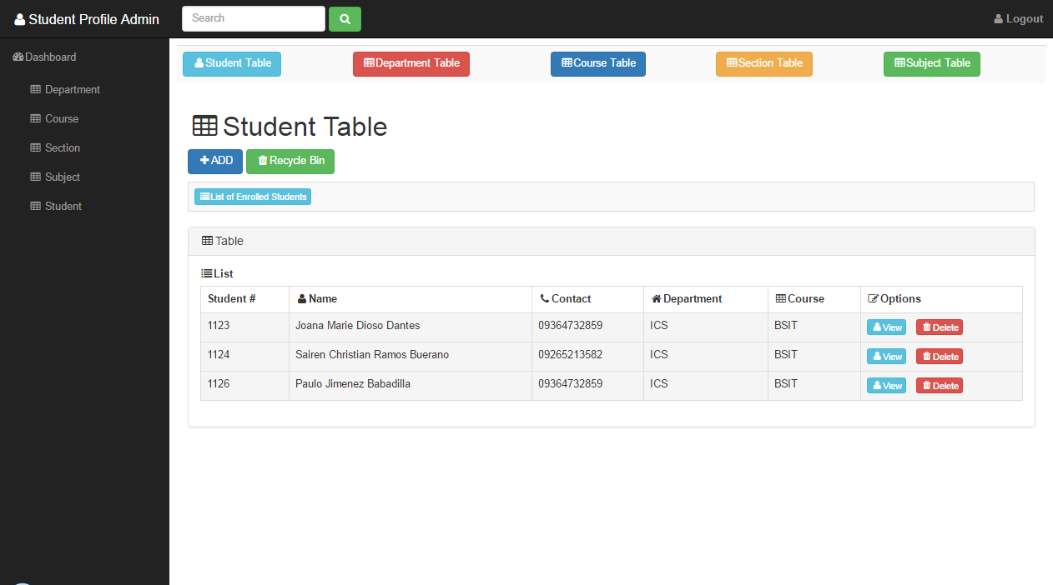

Features (Student Table)

1. Navigation bar – Use to link the other pages and a search bar for corresponding table.
2. Section Link – Use to navigate to view other commands or functions by their corresponding names.
3. Add Student Button – a link to view the add function of the student table.
4. Table – Use to be the output of the data by the corresponding names of the column.
5. Limit Button – Set the limit of the data and pagination
6. View Button – use to visit the page of a certain data that can allow you to add, edit and delete.
7. Delete Button – use to delete corresponding data on a certain row.

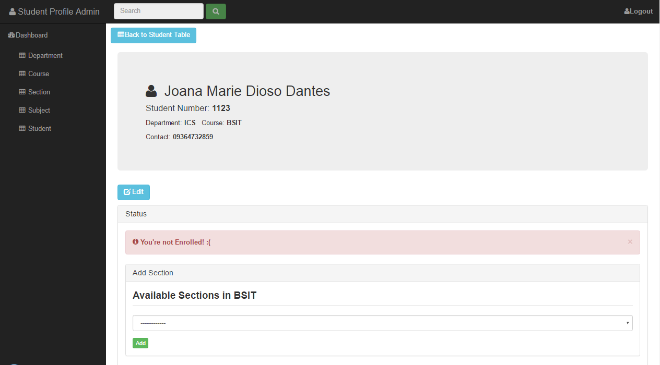

Features (View Page)

* View Page (Edit button) – allows you to edit a certain data.
* Add Section (Add button) – add a significant data that can be found on the database and allows you to access the subject table .

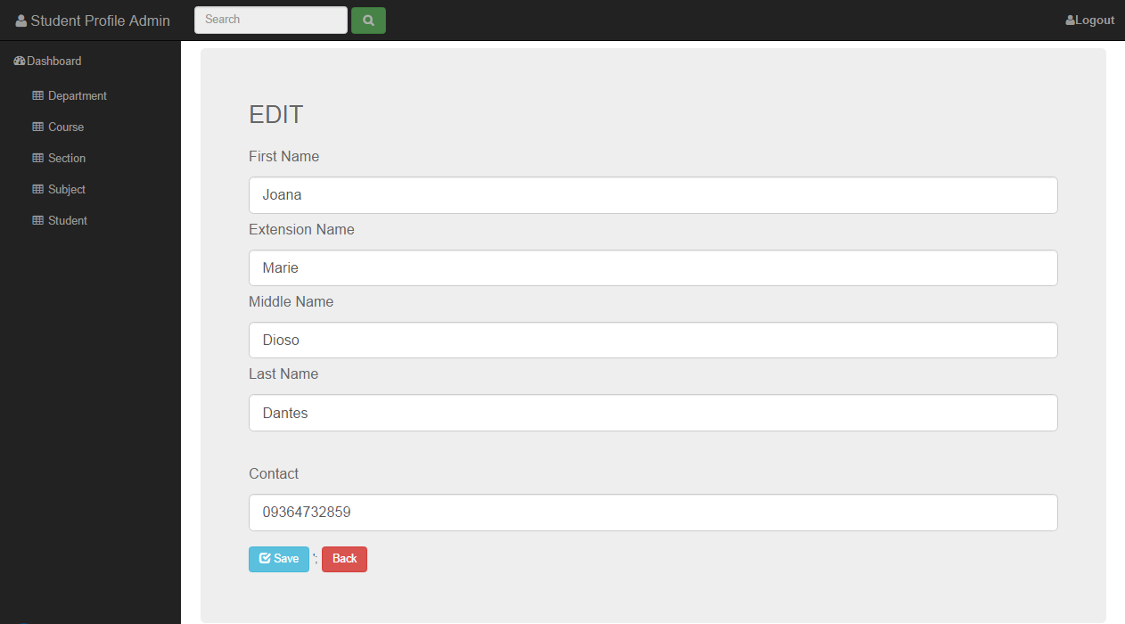

Features (View Edit Page)

* (Save Button) – allows you to save your modified data.
* (Back button) – link back to view page.

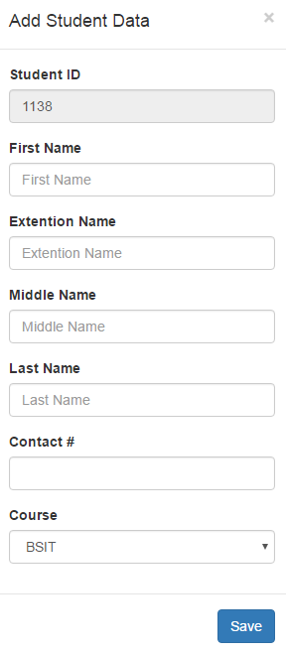

* Add Student Data – allows you to enter all the required data to be add on the database.
* Save button – allows you to save your data.

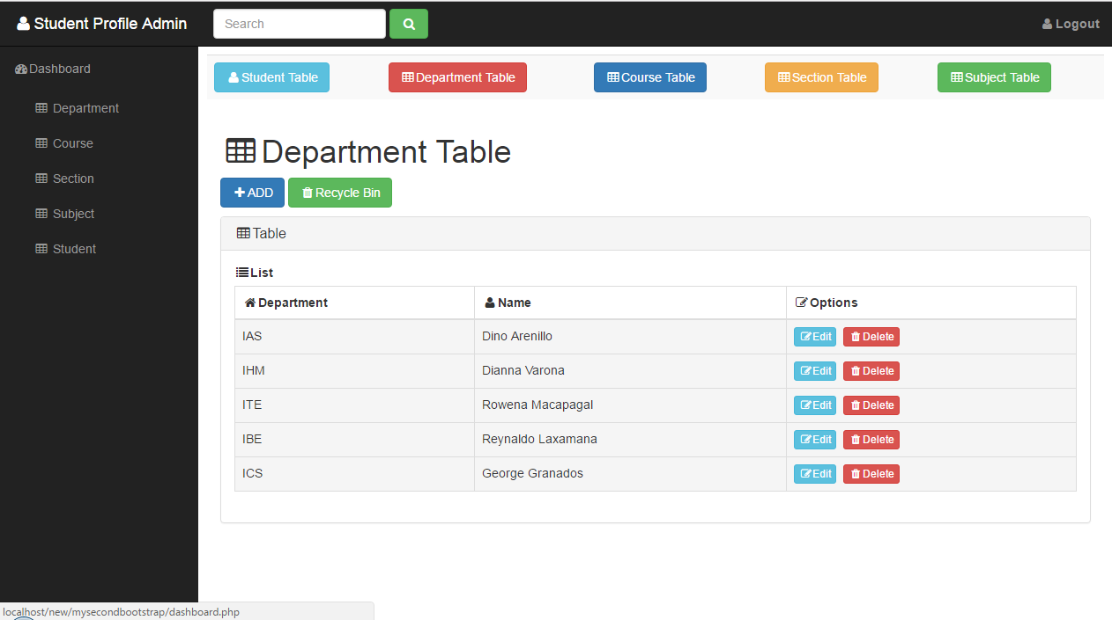

Features (Department Table)

* Navigation bar – Use to link the other pages and a search bar for corresponding table.
* Add Button – a link to view the add function of the department table.
* Table – Use to be the output of the data by the corresponding names of the column.
* Edit Button – use to visit the page of a certain data that allows you to modify and save.
* Delete Button – use to delete corresponding data on a certain row.

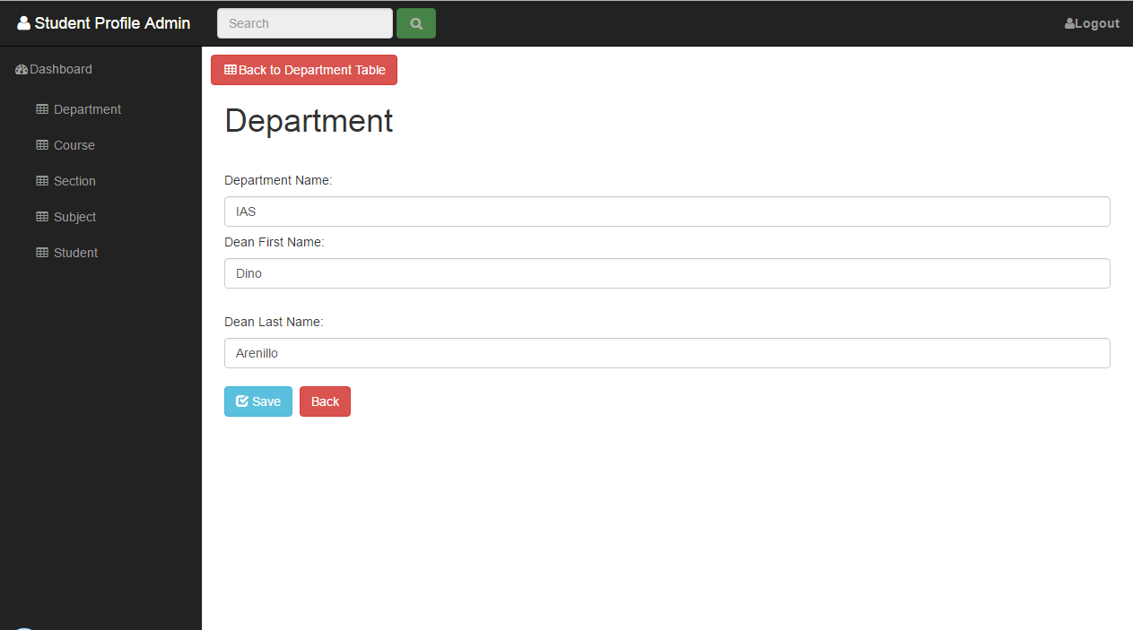

* Department Edit Page (Edit) – allows you to modify a certain data from the database.
* Save button – allows you to save your modified data.
* Back button – link to go back in Department Page.

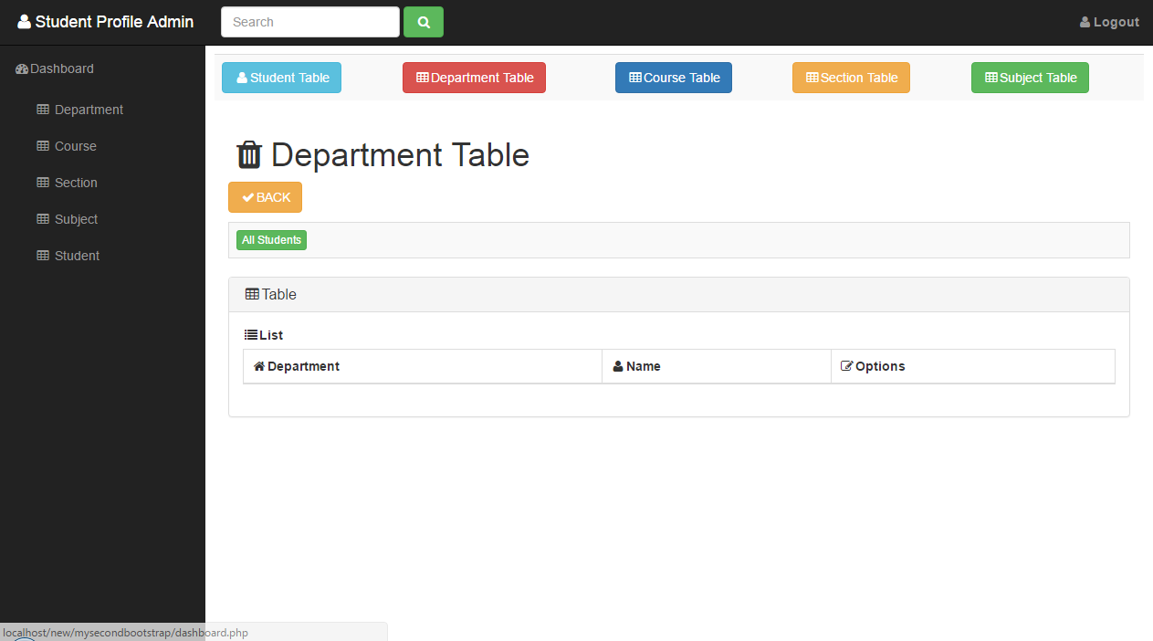

Features (Department Table) Recycle Bin

* Navigation bar – Use to link the other pages and a search bar for corresponding table.
* Add Button – a link to view the add function of the department table.
* Table – Use to be the output of the data by the corresponding names of the column.
* Restore Button – allows you to retrieve the following data.

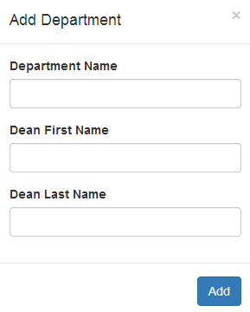

* Add Department Page (Add Department) – allows you to input required information to the database.

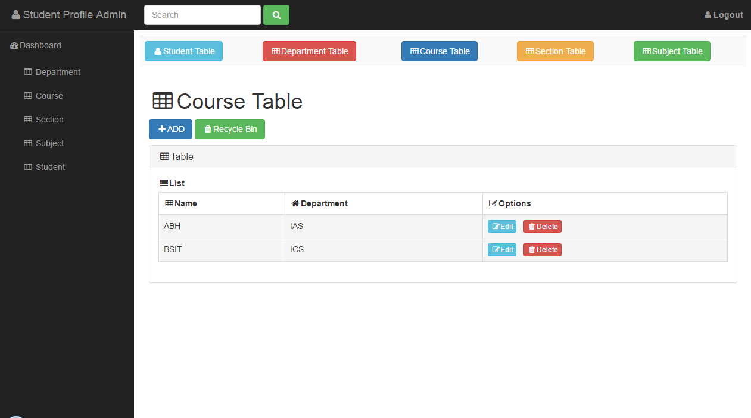

* Course Table – Show all the data that is related to this table
* Edit – allows you to save your modified data.
* Delete – Allows you to delete or to remove data

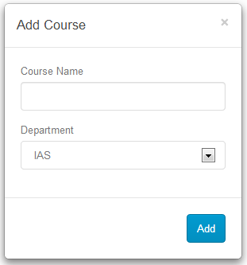

* Add Course Page (Add Department) – allows you to input required information to the database.

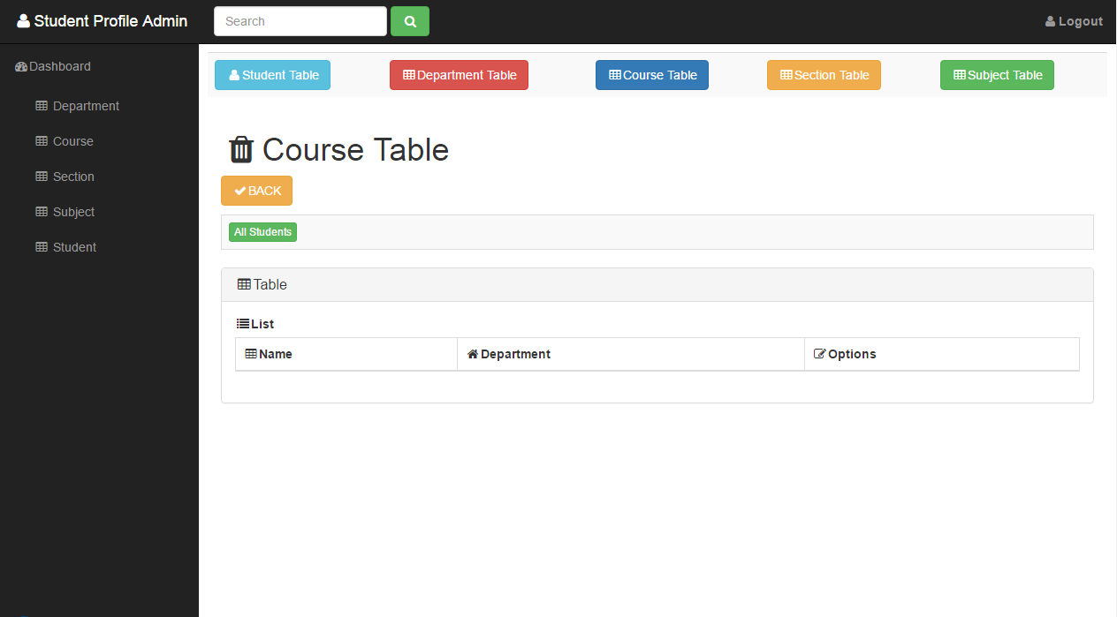

* Course Table (Recycle Bin) – Show all the data that has been deleted
* Restore– allows you to recover or restore the data that has been deleted from the Course Table

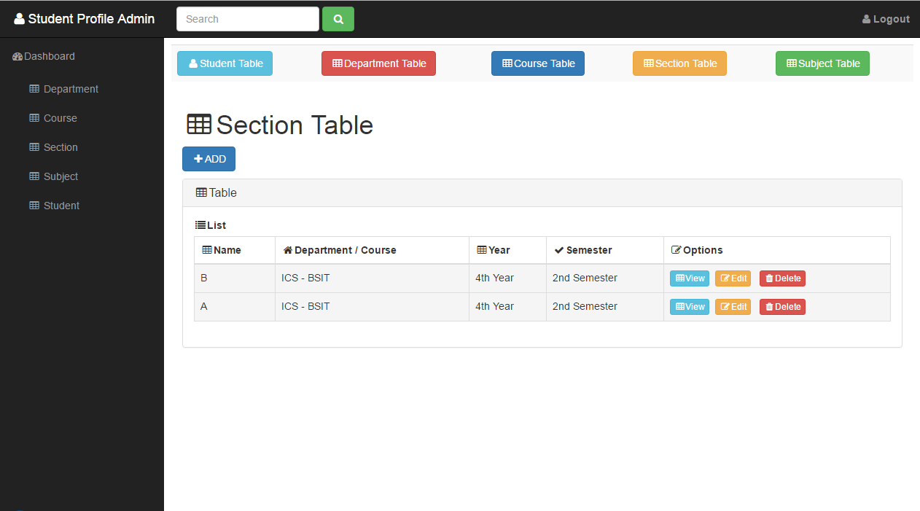

Features (Section)

1. Navigation bar – Use to link the other pages and a search bar for corresponding table.
2. Section Link – Use to navigate to view other commands or functions by their corresponding names.
3. Add Button – a link to view the add function of the department table.
4. Table – Use to be the output of the data by the corresponding names of the column.
5. View Button – use to visit the page of a certain data that can view and navigate to add or remove.
6. Edit Button – use to visit the page of a certain data that can access for the other functions.
7. Delete Button – use to delete corresponding data on a certain row.

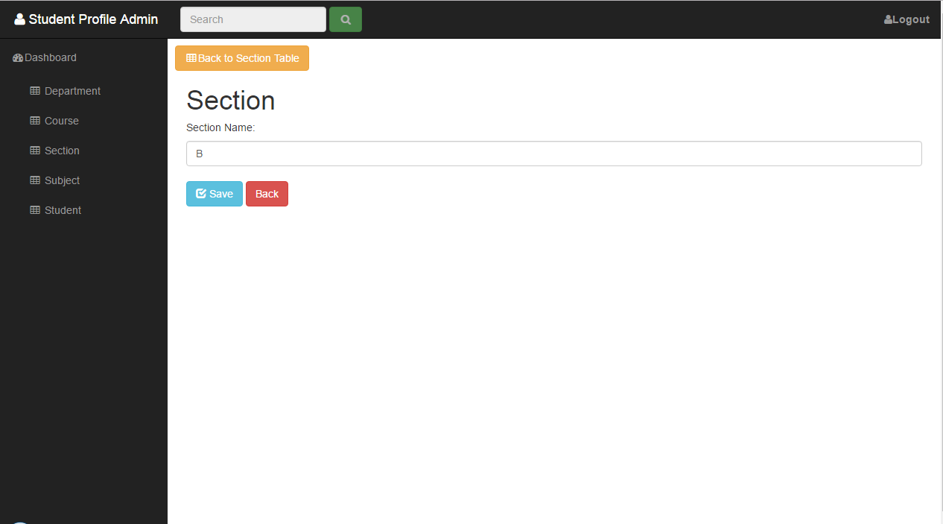

* Section Edit Page (Edit) – allows you to modify a certain data from the database.
* Save button – allows you to save your modified data.
* Back button – link to go back in Department Page.

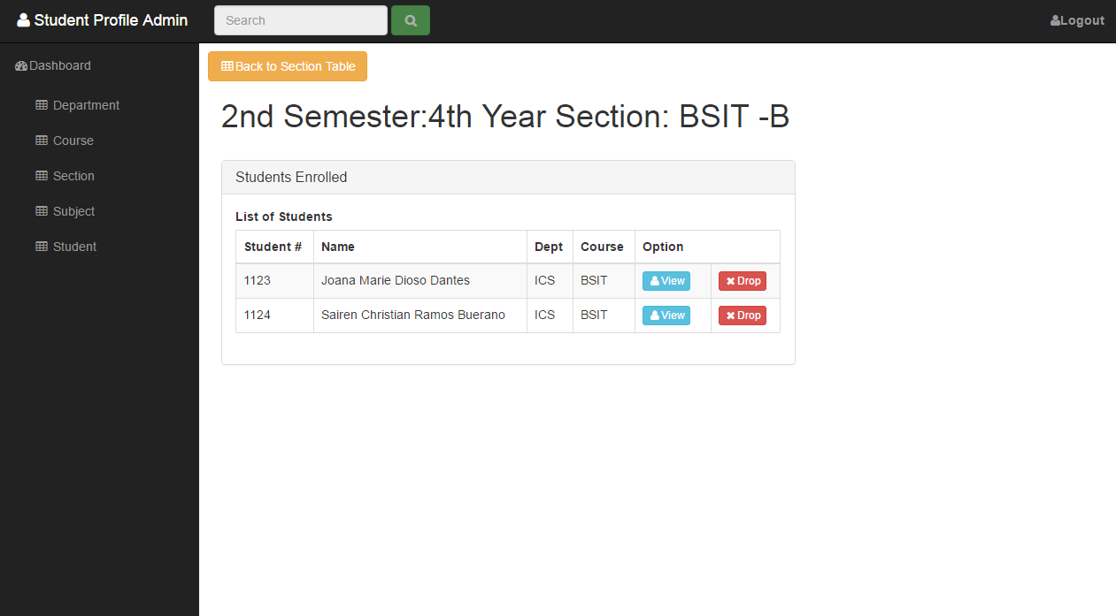

* Section View Page (View) – allows you to view a certain data base on the content that will retrieve from the database.
* View – Allows you to view a student profile that belongs to this section/content
* Drop – Allows you to remove a student in this section

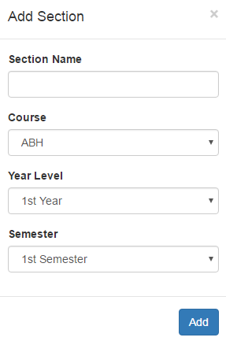

* Add Section Page (Add Section) – allows you to input required information to the database.

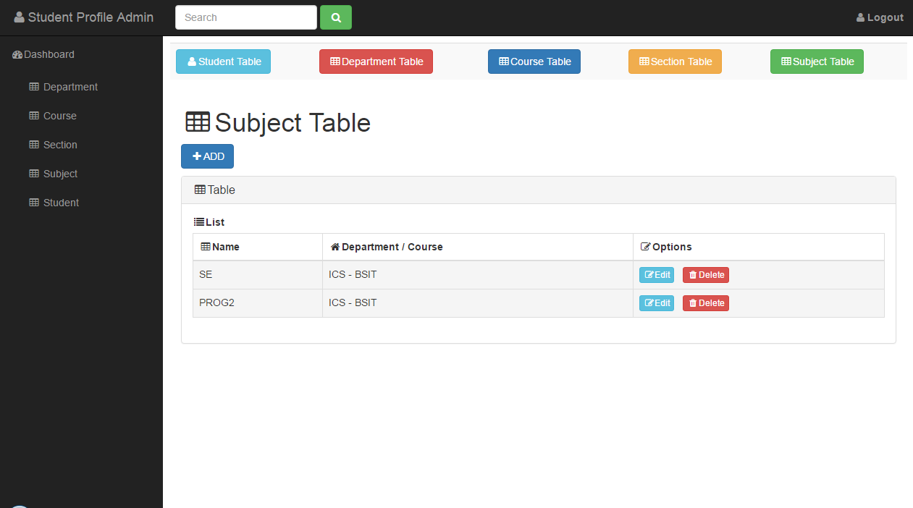

Features (Subject)

1. Navigation bar – Use to link the other pages and a search bar for corresponding table.
2. Section Link – Use to navigate to view other commands or functions by their corresponding names.
3. Add Button – a link to view the add function of the department table.
4. Table – Use to be the output of the data by the corresponding names of the column.
5. Edit Button – use to visit the page of a certain data that can access for the other functions.
6. Delete Button – use to delete corresponding data on a certain row.

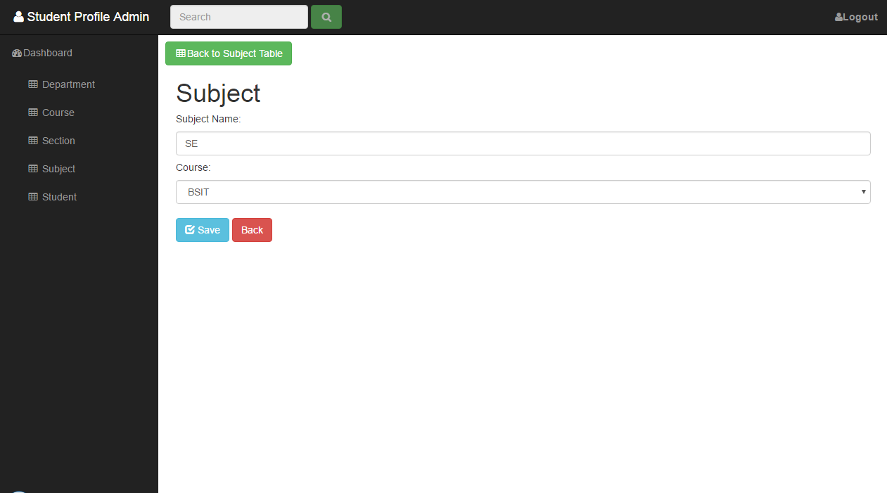

* Subject Edit Page (Edit) – allows you to modify a certain data from the database.
* Save button – allows you to save your modified data.
* Back button – link to go back in Department Page.

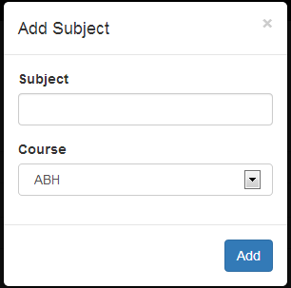

* Add Section Page (Add Subject) – allows you to input required information to the database.

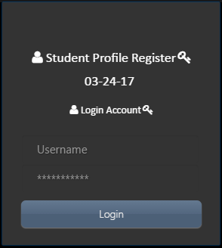

* Initial Login Interface – admin will input his/her valid data to access the system

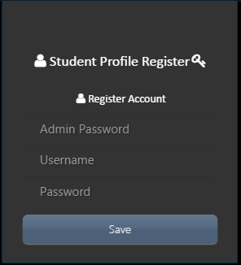

* Initial Register Interface – admin will input his/her valid data to have an access on the system